**Ideation Phase**

**Define the Problem Statements**

|  |  |
| --- | --- |
| Date | 06 May 2023 |
| Team ID | NM2023TMID14694 |
| Project Name | CANCER VISION : Advanced Breast Cancer Prediction with Deep Learning |
| Maximum Marks | 2 Marks |

**Customer Problem Statement Template:**

Create a problem statement to understand your customer's point of view. The Customer Problem Statement template helps you focus on what matters to create experiences people will love.

A well-articulated customer problem statement allows you and your team to find the ideal solution for the challenges your customers face. Throughout the process, you’ll also be able to empathize with your customers, which helps you better understand how they perceive your product or service.

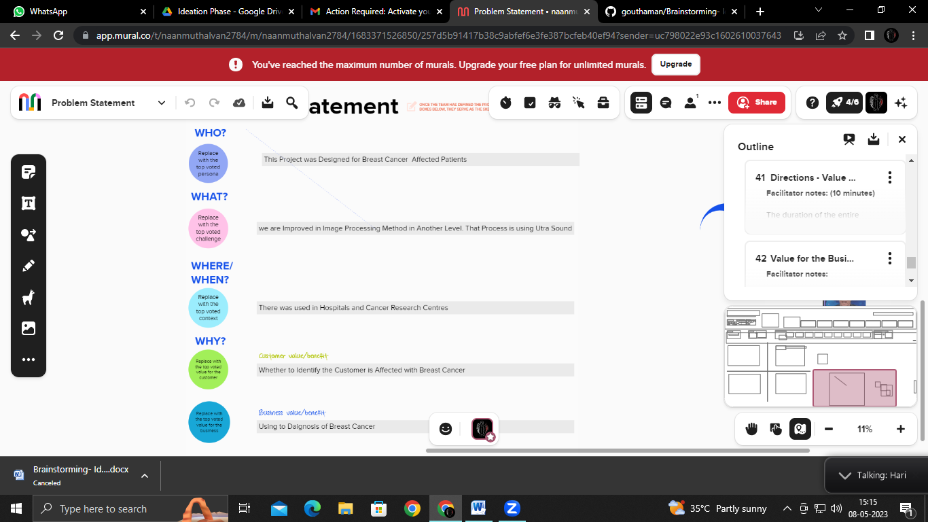

Reference: <https://app.mural.co/t/naanmuthalvan2784/m/naanmuthalvan2784/1683371526850/257d5b91417b38c9abfef6e3fe387bcfeb40ef94?sender=uc798022e93c1602610037643> **Example:**

|  |  |  |  |  |  |
| --- | --- | --- | --- | --- | --- |
| **Problem Statement (PS)** | **I am (Customer)** | **I’m trying to** | **But** | **Because** | **Which makes me feel** |
| PS-1 | Good quality | To Reduce Breast Cancer in World people Population | By Improper Cancer Treatment | Due to Inherited Changes  (Mutation) | Save lives of women’s who is affected by breast cancer |
| PS-2 | Long lasting life | Analysis the Spreaded Breast Cancer in Peoples | Carless of protecting breasts | Certain genes, such as BRCA 1 and BRCA2 | Can be controlled in the starting stage of breast cancers in women’s |